Type the Title of Your Paper Here

First Author  ✉ 1, Second Author  2, Third Author  3

1First affiliation institution, City, Country

2Second affiliation institution, City, Country

3Third affiliation institution, City, Country

✉ [corresponding_author@email.com](mailto:corresponding_author@email.com)

Abstract: The abstract must be concise and factual, does not contain pictures or tables, and cannot exceed 250 words. The abstract must briefly state the research objectives, main results, and conclusions. Abstracts are often presented separately from articles, so they should be able to stand alone. For this reason, References should be avoided, but if necessary, cite the author and year. In addition, non-standard or unusual abbreviations should be avoided, but where necessary, they should be defined at their first mention in the abstract itself.

1. keyword 1; keyword 2; keyword 3.
   1. Introduction (Heading Level 1)

This guideline is a template for writing the manuscript for Jurnal Bina Praja submission and this guideline is available online. Authors are allowed to modify this template for submission purpose.

* 1. Layout

The methods used in solving problems include analytical methods. The image caption is placed as part of the image title (figure caption) and not as part of the image. The methods used in completing the research are written in this section.

* + 1. Word Processing Software (Heading Level 2)

The manuscript should contain between 38.000-40.000 characters (no space) including embedded figures and tables, contain no appendix, and the file should be in Microsoft Office (.doc/.docx) format. Paper should be prepared in A4 paper (21cm x 29.7cm). No need to alter page number in this template as the page number will be reordered at preprinting process.

* + 1. Section Headings

Heading should be made in three levels. Level four cannot be accepted.

* + - 1. Heading Level 3
  1. Structures

The manuscript should begin with title, abstract, and keyword and the main text should consist of: Introduction, Method, Results and Discussion, and Conclusion; followed by Acknowledgment and References.

* + 1. Title

The title of the paper should be brief and informative. Titles are often used in information-retrieval systems. Avoid abbreviations and formulae where possible. Author names should not contain academic title or rank. Indicate the corresponding author clearly for handling all stages of pre-publication and post-publication.

* + 1. Abstract

The abstract should be brief, factual, and state briefly the purpose of the research, the principal results and major conclusions. An abstract is often presented separately from the article, so it must be able to stand alone. For this reason, References should be avoided. Also, non-standard or uncommon abbreviations should be avoided, but if essential they must be defined at their first mention in the abstract itself.

* + 1. Keywords

The keywords should be avoiding general and plural terms and multiple concepts. Be sparing with abbreviations: only abbreviations firmly established in the field may be eligible. These keywords will be used for indexing purposes.

* + 1. Introduction

State the objectives of the work and provide an adequate background, avoiding a detailed literature survey or a summary of the results. Explain how you addressed the problem and clearly state the aims of your study.

* + 1. Methods

State the objectives of the work and provide an adequate background, avoiding a detailed literature survey or a summary of the results. A Theory section should extend, not repeat, the background to the article already dealt with in the Introduction and lays the foundation for further work. a Calculation section represents a practical development from a theoretical basis.

* + 1. Results and Discussion

Results should be clear and brief. Discussion should explore the significance of the results of the work, not repeat them. Avoid extensive citations and discussion of published literature.

* + 1. Conclusion

The main conclusions of the study may be presented in a short Conclusions section, which may stand alone or form a subsection of a Discussion or Results and Discussion section. The conclusion section should lead the reader to important matters of the paper. It also can be followed by suggestions or recommendation related to further research.

* + 1. Acknowledgments

Collate acknowledgments in a separate section at the end of the article before the references and do not, therefore, include them on title page, as a footnote to the title or otherwise. List here those individuals who provided help during the research (e.g., providing language help, or proofreading the article, etc.).

* 1. Preparation
     1. Figures

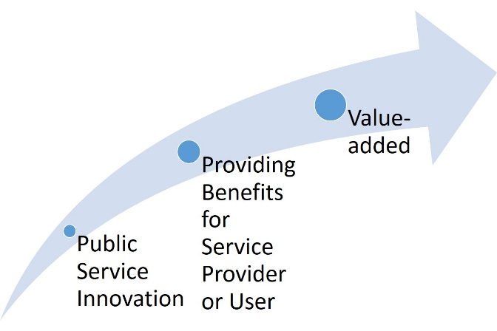Figure should be readable when it later printed. Captions should be numbered. A caption should comprise a brief title (not on the figure itself) and a description of the illustration. Keep text in the illustrations themselves to a minimum but explain all symbols and abbreviations used. The lettering on the artwork should be clearly readable and in a proportional measure. Figures should have a brief description in the main body of text.

Figure . Figure Caption

For layouting purposes, please provide the respective high-resolution figure (≥300dpi) separately in .tif/.jpg/.jpeg within a particular folder apart from the manuscript. Moreover, kindly avoid mentioning position of figure/table e.g. “figure below” or “table as follow” because the position will be rearranged in layouting process. DO NOT put boxes around your figures to enclose them.

* + 1. Table

Number tables consecutively in accordance with their appearance in the text. Place footnotes to tables below the table body and indicate them with superscript lowercase letters. Avoid vertical rules. Be sparing in the use of tables and ensure that the data presented in tables do not duplicate results described elsewhere in the article.

Table 1. Table Caption

|  |  |  |
| --- | --- | --- |
| Position | Name | Political Party |
|  |  |  |
|  |  |  |
|  |  |  |
|  |  |  |

* + 1. Mathematical Equation

Mathematical equation should be clearly written, numbered orderly, and accompanied with any information needed. They should also be separated from the surrounding text.

* + 1. Citation & References

References are recommended using reference management software i.e. Endnote or Mendeley in APA style. References should be listed at the end of the paper and should be listed alphabetically by author’s surname. Authors should ensure that every reference in the text appears in the list of references and vice versa. Please ensure that the page number of each citation is included, except for references that do not have a page number. Wikipedia, personal blog, or nonscientific website is not allowed to be taken into account. Primary references should be at least 80% from at least ten references. References should be taken from the late five years and try to provide a link for each reference.

* 1. Conclusion

This author guideline is the second version of writing template for submitting manuscript into Jurnal Bina Praja. Please do not alter the formatting and style layouts which have been set up in this template document. For inquiries relating to the submission of articles, please visit this journal's homepage at <http://jurnal.kemendagri.go.id/index.php/jbp> or contact Editorial Team at [editorialjbp@jurnal.kemendagri.go.id](mailto:editorialjbp@jurnal.kemendagri.go.id).

Acknowledgement

The guidelines for citing electronic information as offered below are a modified illustration of the adaptation by the International Standards Organization (ISO) documentation system and the American Psychological Association (APA) style.

References

Anderson, B. (2006). *Language and Power: Exploring Political Cultures in Indonesia* (pp. 17-77). Jakarta: Equinox.

Brown, S., & Caste, V. (2004, May). *Integrated obstacle detection framework*. Paper presented at the IEEE Intelligent Vehicles Symposium, Detroit, MI.

Browning, T. (1993). *A brief historical survey of women writers of science fiction*. Retrieved from http://www.cwrl.utexas.edu/~tonya/Tonya/sf/history.html

Henry, W. A., & Mehta, N. S. (1990, April 9). Beyond the melting pot. *Time, 135*, 28-31.

Kuttner, R. (2003, September 8). The great American pension-fund robbery. *Business Week*, 24-26. Retrieved from http://www.businessweek.com/

Lawrence, J. A., &  Dodds, A. E. (2003). Goal-directed activities and life-span development. In J. Valsiner & K. Connolly (Eds.), *Handbook of developmental psychology* (pp. 517-533). London, England: Sage Publications.

Ontario Ministry of Health. (1994). *Selected findings from the mental health supplement of the Ontario Health Survey*. Ottawa, ON: Queen's Printer for Ontario.

Pettigrew, T. F. (2009). Secondary transfer effect of contact: Do intergroup contact effects spread to noncontacted outgroups? *Social Psychology, 40*(2), 55-65. doi:10.1027/1864-9335.40.2.55

Severson, K. &, Martin, A. (2009, March 3). It's organic, but does that mean it's safer? *The New York Times*. Retrieved from http://www.nytimes.com

Wallace, K. (2007, December 4). Passport applicant finds massive privacy breach. *The Globe and Mail*, pp. A1, A8.

Wilkinson, R. (1999). Sociology as a marketing feast. In M. Collis, L. Munro, & S. Russell (Eds.), *Sociology for the New Millennium*. Paper presented at The Australian Sociological Association, Monash University, Melbourne, 7-10 December (pp. 281-289). Churchill, VIC: Celts.